|  |  |  |  |  |
| --- | --- | --- | --- | --- |
|  |  | | |  |
| **OceanProtect A8000**  **1.0.0** | | |
| **Demo User Guide** | | |
| **Issue** | **01** | |
| **Date** | **2021-09-30** | |
|  | | | | |
|  | HUAWEI TECHNOLOGIES CO., LTD. | |  |  |

|  |
| --- |
| **Copyright © Huawei Technologies Co., Ltd. 2021. All rights reserved.**  No part of this document may be reproduced or transmitted in any form or by any means without prior written consent of Huawei Technologies Co., Ltd.  **Trademarks and Permissions**  and other Huawei trademarks are trademarks of Huawei Technologies Co., Ltd.  All other trademarks and trade names mentioned in this document are the property of their respective holders.  **Notice**  The purchased products, services and features are stipulated by the contract made between Huawei and the customer. All or part of the products, services and features described in this document may not be within the purchase scope or the usage scope. Unless otherwise specified in the contract, all statements, information, and recommendations in this document are provided "AS IS" without warranties, guarantees or representations of any kind, either express or implied.  The information in this document is subject to change without notice. Every effort has been made in the preparation of this document to ensure accuracy of the contents, but all statements, information, and recommendations in this document do not constitute a warranty of any kind, express or implied. |

|  |  |
| --- | --- |
| Huawei Technologies Co., Ltd. | |
| Address: | Huawei Industrial Base  Bantian, Longgang  Shenzhen 518129  People's Republic of China |
| Website: | <https://e.huawei.com> |

About This Document

Overview

This document describes how to use the OceanProtect A8000 demo version.

Intended Audience

This document is intended for operators who need to set up the OceanProtect A8000 demo environment.

Symbol Conventions

The symbols that may be found in this document are defined as follows.

| Symbol | Description |
| --- | --- |
|  | Indicates a hazard with a high level of risk which, if not avoided, will result in death or serious injury. |
|  | Indicates a hazard with a medium level of risk which, if not avoided, could result in death or serious injury. |
|  | Indicates a hazard with a low level of risk which, if not avoided, could result in minor or moderate injury. |
|  | Indicates a potentially hazardous situation which, if not avoided, could result in equipment damage, data loss, performance deterioration, or other unanticipated results.  NOTICE is used to address practices not related to personal injury. |
|  | Supplements the important information in the main text.  **NOTE** is used to address information not related to personal injury, equipment damage, and environment deterioration. |

Change History

| Issue | Date | Description |
| --- | --- | --- |
| 01 | 2021-09-30 | This issue is the first official release. |

Contents

About This Document ii

1 Preparing for the Installation 1

1.1 Requirements for the Operating System 1

1.2 Checking the Demo Software Installation Package 1

1.2.1 Software Installation Package Checklist 1

1.2.2 File Checklist After Decompression 1

1.3 Checking Whether the Port Is Occupied 2

2 Using the Demo 3

2.1 Starting and Stopping the Demo 3

3 Features Overview 5

3.1 Homepage 5

3.2 Protection 5

3.3 Data Utilization 5

3.4 Monitoring 6

3.5 System 6

3.6 Global Search 6

# Preparing for the Installation

1.1 Requirements for the Operating System

1.2 Checking the Demo Software Installation Package

1.3 Checking Whether the Port Is Occupied

## Requirements for the Operating System

* The OceanProtect A8000 demo version can be used only in the Windows environment and supports both 32-bit and 64-bit versions of Windows.
* The browser must be Chrome 78.0 or a later version.

## Checking the Demo Software Installation Package

### Software Installation Package Checklist

| No. | Check Item | Size |
| --- | --- | --- |
| 1 | OceanProtect_A8000_Demo.zip | About 50 MB |

### File Checklist After Decompression

| No. | File Name | Description |
| --- | --- | --- |
| 1 | OceanProtect_A8000 _Demo.exe | Demo program installation package |
| 2 | OceanProtect A8000 1.0.0 Demo User Guide.docx | Demo user guide |
| 3 | stop.bat | Script for stopping the demo program |
| 4 | db | Data source directory |

## Checking Whether the Port Is Occupied

Port 4300 will be used when the OceanProtect A8000 demo system is running. Ensure that the port is not occupied. If the port is occupied, run the **netstat -ano|findstr 4300** command to find the process and stop it, or directly run the tool script **stop.bat**.

# Using the Demo

2.1 Starting and Stopping the Demo

## Starting and Stopping the Demo

Starting the Demo

Decompress **OceanProtect_A8000_Demo.zip** to obtain the following files:

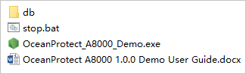

Double-click **OceanProtect_A8000_Demo.exe**. After port 4300 is listened, the system automatically opens the browser, which is then redirected to the login page. You can enter any user name and password.

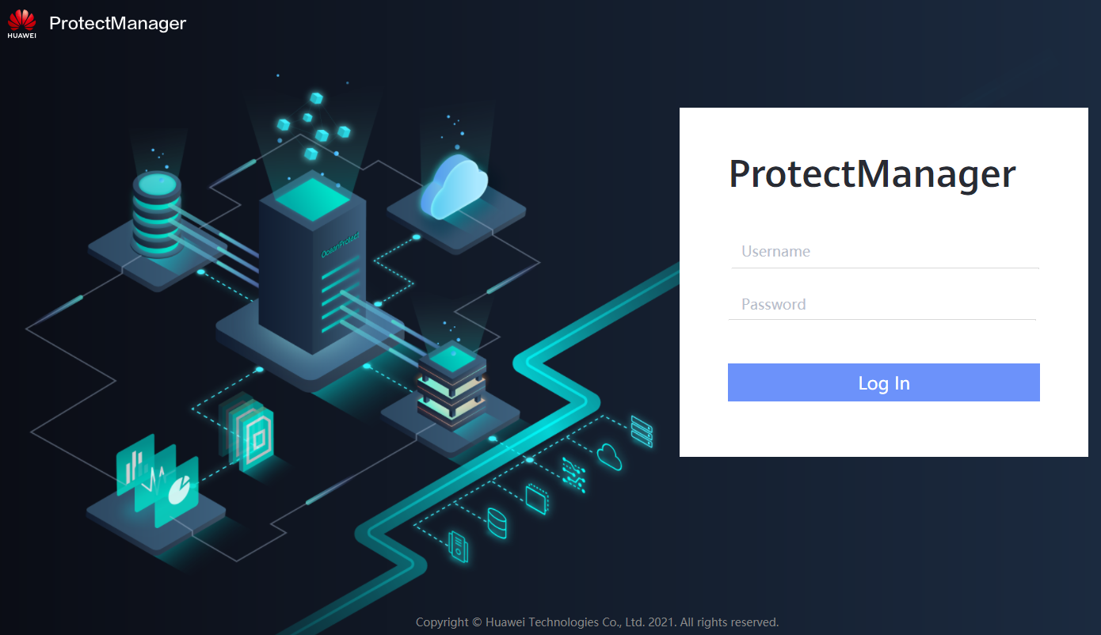

----End

Stopping the Demo

Double-click **stop.bat** and wait until the process of port 4300 is stopped.

# Features Overview

3.1 Homepage

3.2 Protection

3.3 Data Utilization

3.4 Monitoring

3.5 System

3.6 Global Search

## Homepage

* The OceanProtect A8000 demo version supports statistical collection of tasks, resource protection, alarm severities, system capacity, capacity prediction, data reduction, and performance monitoring.

## Protection

* The three applications (fileset, Oracle, and VMware) simulate the functions such as SLA protection, copy-based recovery, background task generation, deactivation, protection activation, authentication information modification, protection removal, and protection modification in the real environment.
* Except the application protection modules fileset, Oracle, and VMware, other applications use the three data records preset in the database. They are only responsible for data display, but do not apply linkage effects.
* The service level agreement (SLA) can be created, deleted, cloned, and modified.
* Three data records are preset in the rate limiting policy and can be displayed in a list.

## Data Utilization

* Three data records are preset in the resource list view under the copy data menu. Resource details can be viewed.
* Three data records are preset in the copy list view under the copy data menu. You can view the copy details and click a resource name to view the copy data. Only restore, instant restore, live mount, and retention policy modification can be performed in the operation column.
* You can create, destroy, modify, update, migrate, activate, disable, and view basic information about Oracle and VMware live mount.
* Three data records are preset in the mount update policy and can be displayed in a list.
* Data anonymization (anonymization policy, identification rule, and anonymization rule) can only be viewed.

## Monitoring

* Three data records are displayed in the alarm and event lists, respectively.
* Preset task and performance data can be viewed on the task and performance pages, and the performance data can be updated at a regular interval.

## System

All GUI functions support only data browsing and display.

## Global Search

Quick search can be performed based on different conditions.